**CAREER OBJECTIVE**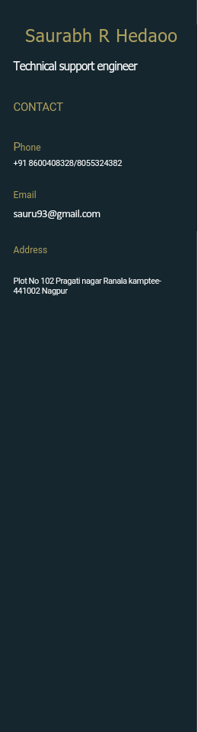



Adequate and Quality-oriented professional with 2.1 years of experience and a proven knowledge of Computer networking, network monitoring and troubleshooting. Aiming to leverage my skills to successfully gain the Technical/Network support engineer role at your company.

**EXPERIENCE**

Next Education India Pvt Ltd, Pune

**Technical Support Engineer :(** 2year 1month). 23Aug2018-20Sept2020.

* Provide Technical/Network Support services to the IT user community.
* Respond to IT incidents and requests received from Remedy tickets escalated from the Service Desk.
* maintain servers, hardware, and software on Windows platform
* installs and configure software, network monitoring, migrate data
* Windows/Microsoft Office account Creation and Add user account and give priority.
* Troubleshoot and resolve user incidents and requests dealing with the Microsoft operating system, Active Directory, Microsoft Office Suite, Citrix, and VPN.
* Deploy hardware and software to fulfill user requests.
* Joining the domain, move users profile Installation of desktop hardware and software applications, security updates, and security packs.
* Troubleshoot, documented and resolved all technical issues pertaining to MS Windows XP, Office 2007, 2008, 2010 Network Connectivity, and hardware related issues.
* Setup and configuration of handheld devices (e.g.iOS/Palm/Android) outlook email in enterprise environment.
* Troubleshoot and maintain all Dell, Cannon, Xerox, and HP (Printers and Scanners) on Windows 2007/10 Print Server.
* Trains workers in use of new software or hardware.
* Installs new hardware and maintains existing hardware.
* Supports and maintains user account information including rights, security and systems groups.
* System hardware and software end user support including Network connectivity, Windows 7 and 10 clients, Norton/Quick Heal Antivirus, and Microsoft Office.
* Analyzes complex network problems and coordinates resolutions.
* Supports and maintains user account information including rights, security and systems groups.
* System hardware and software end user support including Network connectivity, Windows 7/8/10 and XP clients, Norton/Quick Heal Antivirus, and Microsoft Office.

**EDUCATION**

**G S College of Commerce and Economics Nagpur, Maharashtra**

M.B.A in Finance and Marketing, Percentage: 61%, Passing year: July 2018

**Anjuman College of Engineering and Technology Nagpur, Maharashtra**

B.E in Electronics and Telecommunication, Percentage: 58.72%, Passing year: June 2015

**S K Porwal College Nagpur, Maharashtra**

Higher Secondary School certificate exam, Percentage: 68%, Passing year: Feb 2011

**St Joseph Convent High School Nagpur, Maharashtra**

Secondary School certificate exam, Percentage: 77%, Passing year: March 2009

**DECLARATION**

I hereby declare that, above information is true to the best of my knowledge.