****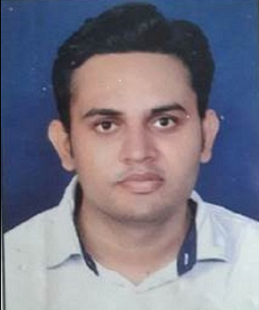 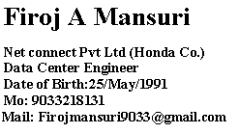



A highly competent and organized systems administrator with experience of software procurement, installation, administration & compatibility. Possessing a proven ability to assist with the day-to-day running of an IT department and its business IT systems. Extensive knowledge of monitoring and controlling data security within guidelines to ensure compliance and report on possible improvements. Well mannered, articulate and able to act as point of contact for colleagues and external clients.

Looking for a suitable IT administrator position with an exciting, innovative and ambitious company that offers room for progression.

**Work Experience:**

|  |  |  |  |  |
| --- | --- | --- | --- | --- |
| Company | Client | Designation | Location | Duration |
| **Kaizen IT service pvt ltd** | **Incometax Office** | **FMS Engineer** | **Ahmedabad** | **12/Jan/15 to 24/Sep/16** |
| **Dixit Infotech pvt ltd** | **Reliance Industries** | **Service Desk Engineer** | **Dahej**  **(Bharuch)** | **01/Oct/16 to 11/March/17** |
| **Tech Mahindra ltd** | **NuFuture Group India** | **Associate Analyst** | **Ahmedabad** | **20/Nov/17 to 29/Aug/19** |
| **BeekayIT NetSec solution pvt ltd** | **Cera Sanitaryware** | **Desktop Support L2 Engineer** | **Kadi** | **11/Dec/19 to 31/May/20** |
| **Net Connect pvt ltd** | **Honda company** | **Data Center Engineer** | **Vithlapur**  **(Ahmedabad)** | **14/July/20 to Present** |

**Current Job Duties:**

* Handling 9 virtual server in VMware and 3 physical server
* Managing Backup server activity daily basis
* Managing data center all devices and component
* In WSUS managing and processing system update
* Using firewall, manage client security policy and permission.
* Monitoring network connectivity and troubleshooting whole company infrastructure.
* Setting up New Users, Deleting & Disabling User Accounts, User Profiles, Logon Restriction
* Managing asset inventory and call attending by ticketing tools.
* Maintaining Client Computers, Domain and Local User Accounts.
* Setting up New Users, Deleting & Disabling User Accounts, User Profiles, Logon Restriction
* Managing Internet access to users as per client requirements.
* Using Veritas NetBackup app Backup data schedule on daily basis. Process to backup file and restoration process.
* Basic Troubleshooting and monitoring WAN link status and connection.
* Manage and maintain Active Directory User Account, OU & GPO
* Managing file sharing and quota management for user data.

**Key Skills**

**Tools**: VMware, Whatsup Gold, Veritas NetBackup, Solar Winds, Arcon PAM,

Lansweeper, RVTools, TFTP,IP Scanner,

**Ticketing Tools**: ITShayak, Snow Tools, Tivoli, Co-desk, Dristi

**Hardware**: In depth knowledge in Computer, Printer and Scanner Hardware

**Server**: Active Directory, Win-2008-12-19 installation and configuration,

GPO, DHCP, DNS, TCP-IP, UDP, FSRM, VMware, DFS, IIS, FTP, WDS, WSUS, RAID,

Backup Server, File server, Linux & SQL basic

**Network**: knowledge of LAN and WAN, Switching, Topology network, Wi-Fi,

**ACADEMIC QUALIFICATIONS**

|  |  |  |  |  |
| --- | --- | --- | --- | --- |
| **EDUCATION** | **BORD** | **COLLEGE** | **YEAR** | **RESULT** |
| **B.Tech CSE** | **NIMS UNIVERSITY** | **N.I.E.T**  **JAIPUR** | **2013** | **58.84 %** |
| **Diploma CSE** | **TEB** | **A.V.P.T.I RAJKOT** | **2010** | **53.96 %** |
| 10th | **GSEB** | **M.S.SANGHI VIDHYALAY** | **2006** | **75.29 %** |

**Certification Details**:

* **MCP**: Windows Server 2012

Certification Number-G073-9460

* **MCSA**:Windows Server 2012

Certification Number- G076-2142

* Microsoft Certification ID-14420432
* **BSNL**: telephone exchange service practitioner

**PERSONAL DETAILS**

Permanent Address: Present Address:

Near small masjid Delwada Room No-15 Omkar residence,

Ta-Una Dist-Gir Somnath (362510) Tirth apartment near,

Kadi Mehsana(382715)

M: 9033218131

E-Mail: [Firojmansuri9033@gmail.com](mailto:Firojmansuri9033@gmail.com)

Status: Married

Passport Number: R2961632

DOB: 25/05/1991

Nationality: Indian

I hereby declare that the above information’s are true to the best of my knowledge. I will be humbly grateful if given a chance to work in your esteemed organization.

Firoj Mansuri