**RESUME**

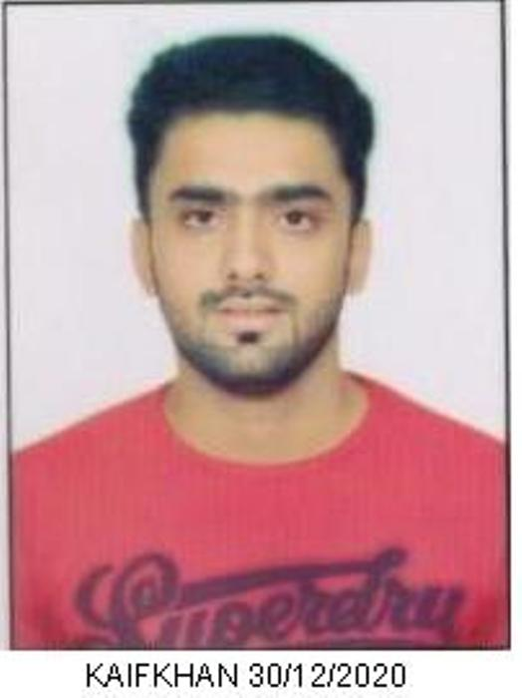

**PATHAN KAIFALIKHAN NISSARKHAN**

4719/2, Amin Mnzil, Khamasa,

Jamalpur, Ahmedabad-380001

**Contact: 8155810083, 9173856688**

**E-mail:** [**pathankaif20@gmail.com**](mailto:pathankaif20@gmail.com)

**OBJECTIVE**

To utilize my skills in an innovative manner and at the same time improve them through

process of Constant learning to serve with professional integrity.

**EDUCATIONAL QUALIFICATIONS**

|  |  |  |  |
| --- | --- | --- | --- |
| **Degree** | **Board/University** | **Year of Passing** | **Percentage/ CGPA** |
| **M.E(Computer Engineering)** | Gujarat Technological University. Gujarat | 2021 | Pursuing |
| **B.E(Computer Engineering)** | Gujarat Technological University, Gujarat | 2019 | CGPA-6.89  63.90% |
| **H.S.C(Science)** | (G.H.S.E.B) | 2015 | 46.00% |
| **S.S.C** | (G.S.E.B) | 2013 | 62.50% |

**TECHNICAL SKILLS**

* MS-Office
* Operating System: Windows,Linux
* Programming:- Python,DjangoFramework,CSS,HTML, SQL

**AREAS OF INTEREST**

* Programming
* Web Development

**TRAINING EXPERIENCE**

* 3 Months of Training Experience in Python,Django Framework at AGILE Academy Pvt.Ltd Nehrunagar, Ahmedabad

**EXPERIENCE**

* Currently Working in CMS IT Services Ltd as a Associate Trainee Engineer since Last 8 Months.

**PERSONAL SKILLS**

* Good communicator having verbal and written communication skills.
* Willingness to learn new things.
* Strengths: Positive & Simple attitude, Self Confident.
* Languages known: English, Hindi, Gujarati.

**DECLARATION**

I hereby declare that the above statements made are complete and true to my knowledge.

**K.N.PATHAN**