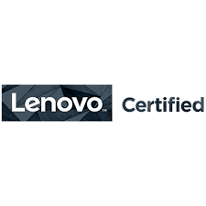
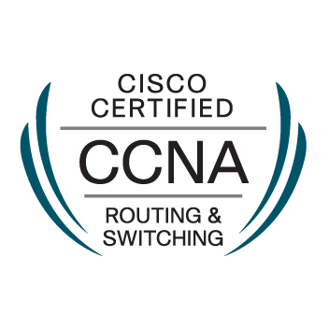
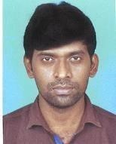
Resume

PANCHANAN BHUNIA
Mobile No. +91 8902312523
Mail:panchanan0012@gmail.com

CAREER OBJECTIVE:
I am Cisco Certified Network Associate also with Lenovo Certified. I am a self-motivated, confident, enthusiastic, team spirited player who loves facing challenges. I firmly believe in “conformation to requirement”. I am a cooperative person who loves quality, perfection and teamwork.
JOB EXPERIENCE:
Organization: New wave Computing PVT Ltd (Bangalore)
Role : FMS Engineer (Cognizant-Kolkata).
Duration: From 19 May 2016 to present.
……………………………………………………………………………………………………………………………………
Job Responsibilities:
- Troubleshooting various connectivity issues of internal users, raised through Remedy portal (Global Service Desk).
- Resolving IP Phone configuration installation and daily issue.
- Having hands-on experience on switching, which consists of creating, implementing and managing VLANs.
- Troubleshooting and implementing port based security, which is a part of port security applied to internal users.
- Raising change requests for implementing new connectivity / configuration changes as and when required.
- Installing and resolving Wi-Fi Access point, Modems issues.
- Network printer configuration & maintains.
- Co-ordination with local support engineers from vendors during new architectural implementation/up gradation activity.
- OS deploy in laptop & desktop through SCCM/WDS.
- Drive encryption in laptop through Bit Locker.
- Issue detect and Problems Resolved with in SLA time.
- Installation of Various Software/Drivers and problems resolving.
- FMS Engineer to Support Respective floors and compliance.
VC Device/TV/IP phone maintain.
……………………………………………………………………………………………………………………………………
- Organization: Nutech Technology(Kolkata)
- Role : System Engineer
- Company/client: Field Support
- Duration: From July 2014 to 15 May 2016.
……………………………………………………………………………………………………………………………………
Job Responsibilities:
- New system sale/AMC contract.
- Configure Outlook Express & MS Outlook & troubleshoot any kind of problem is occurred in the mail client.
- Identified and resolved all kinds of hardware and software issues at client.
- Maintenance all Lenovo Dell HP Model Laptops and desktops.
- Hardware/Software Support for end-users.
- Maintain Laptop bit locker for data security.
- Network printer configuration & maintains.
- Working with System and Software compliance.
- Install windows Server 2003, 2008 R2, 2012, and configure role base futures.
- Planning CCTV installation & services with support.
- Biometric Installation and services with support (Secure-Eye).
……………………………………………………………………………………………………………………………………
Technical Expertise:

Infrastructure Related-
- Having Knowledge Windows server, Linux (access part), Network Topology, citrix (client).
- Having little Knowledge Exchange server, office 365 mail, Active Directory.
- WAN Networking, LAN Networking Upgrading and Maintenance.
- Having Knowledge of TCP/IP (IPV4 & IPv6), DNS, and DHCP.
- Having knowledge OSPF, EIGRP, RIPng, EIGRP, and BGP.
- Configuration of VLAN, VTP, VTP, Server STP, Ether Chanel, Stacking, Virtual Chassis.
- Implement switch port and MAC based security and NAT, PAT.
- IP Phone configuration and installation.
Operating Related:
- Well knowledge of Windows Operating System (Client and Server OS Installation & configuration).
- Linux operating system (access part)
- OS related problem resolving, and antivirus maintains.
- Troubleshooting various hardware related problems, which creates OS issue.
- Printer and other peripheral device configuration and installation.
Installation multiple software, Outlook Mail configuration etc. PST, data back-up • RDP, Admin access, security group, DL , map drive, share path etc.
Mail ID:panchanan0012@gmail.com/Cell-8902312523

EDUCATION & CERTIFICATIONS
- UG/Bachelor’s (UNIVERSITY OF CALCUTTA).
- Diploma in Hardware & Networking - State youth Computer center.
- Gandhi Institute of Computer education & Information Technology (DTP).
- Lenovo Certified Engineer (CompTIA+ TECH ID NC1307576).
- HP Expert one (VP global Certification).
- CCNA course (Cisco Network Academy).
- Cybersecurity Essentials Course (Cisco Network Academy).
- CCNA (Cisco certified-CSCO13431317).
- Azure Administrator (On going).

- Key Strengths:
- Ability to learn new technology.
- Enthusiastic to upgrade myself in the technical aspects from time to time.
- Strong analytic and problem solving skills with an ability to make well decisions.
- Ability to work independently as well as within a team.
- Commitment to high ethical standards.
- Familiar with 24x7 shift.
- Notice period – 30 days.
- Mail:panchanan0012@gmail.com
- Contact:8902312523
- Total Experience 5.6 Years.
Personal Information:
Name | : Panchanan Bhunia
Father Name | : Chandi Charan Bhunia
Address (Local) | : Trinath pally, P.O- Nowbhanga, South Bidhan Nagar. Kolkata PIN-700105.
Nationality | : Indian
Marital Status | : Single/Unmarried
Language Known | : English, Bengali and Hindi.
Declaration:

I hereby declare that all the information’s given above are true and correct to best of my
Knowledge, belief, and I hold the responsibility of its authenticity.

Date: 24.01.2020
Place: Kolkata
Panchanan Bhunia

