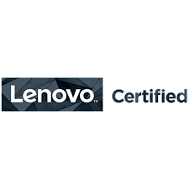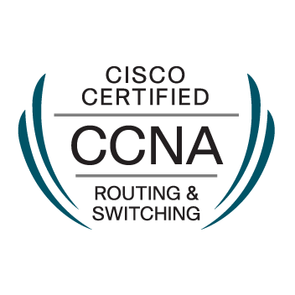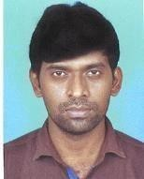 **Resume**

PANCHANAN BHUNIA

Mobile No. +91 8902312523

Mail:panchanan0012@gmail.com

**CAREER OBJECTIVE:**

I am Cisco Certified Network Associate also with Lenovo Certified. I am a self-motivated, confident, enthusiastic, team spirited player who loves facing challenges. I firmly believe in “conformation to requirement”. I am a cooperative person who loves quality, perfection and teamwork.

**JOB EXPERIENCE:**

|  |  |
| --- | --- |
|  |  |

**Organization: New wave Computing PVT Ltd (Bangalore)**

**Role : FMS Engineer (Cognizant-Kolkata).**

**Duration: From 19 May 2016 to present.**

**……………………………………………………………………………………………………………………………………**

**Job Responsibilities:**

* Troubleshooting various connectivity issues of internal users, raised through Remedy portal (Global Service Desk).
* Resolving IP Phone configuration installation and daily issue.
* Having hands-on experience on switching, which consists of creating, implementing and managing VLANs.
* Troubleshooting and implementing port based security, which is a part of port security applied to internal users.
* Raising change requests for implementing new connectivity / configuration changes as and when required.
* Installing and resolving Wi-Fi Access point, Modems issues.
* Network printer configuration & maintains.
* Co-ordination with local support engineers from vendors during new architectural implementation/up gradation activity.
* OS deploy in laptop & desktop through SCCM/WDS.
* Drive encryption in laptop through Bit Locker.
* Issue detect and Problems Resolved with in SLA time.
* Installation of Various Software/Drivers and problems resolving.
* FMS Engineer to Support Respective floors and compliance.

VC Device/TV/IP phone maintain.

……………………………………………………………………………………………………………………………………

* **Organization: Nutech Technology(Kolkata)**
* **Role : System Engineer**
* **Company/client: Field Support**
* **Duration: From July 2014 to 15 May 2016.**

……………………………………………………………………………………………………………………………………

**Job Responsibilities:**

* New system sale/AMC contract.
* Configure Outlook Express & MS Outlook & troubleshoot any kind of problem is occurred in the mail client.
* Identified and resolved all kinds of hardware and software issues at client.
* Maintenance all Lenovo Dell HP Model Laptops and desktops.
* Hardware/Software Support for end-users.
* Maintain Laptop bit locker for data security.
* Network printer configuration & maintains.
* Working with System and Software compliance.
* Install windows Server 2003, 2008 R2, 2012, and configure role base futures.
* Planning CCTV installation & services with support.
* Biometric Installation and services with support (Secure-Eye).

……………………………………………………………………………………………………………………………………

**Technical Expertise:**

**Infrastructure Related-**

* Having Knowledge Windows server, Linux (access part), Network Topology, citrix (client).
* Having little Knowledge Exchange server, office 365 mail, Active Directory.
* WAN Networking, LAN Networking Upgrading and Maintenance.
* Having Knowledge of *TCP/IP (IPV4 & IPv6),* DNS, and DHCP.
* Having knowledge OSPF, EIGRP, RIPng, EIGRP, and BGP.
* Configuration of VLAN, VTP, VTP, Server STP, Ether Chanel, Stacking, Virtual Chassis.
* Implement switch port and MAC based security and NAT, PAT.
* IP Phone configuration and installation.

**Operating Related:**

* Well knowledge of Windows Operating System (Client and Server OS Installation & configuration).
* Linux operating system (access part)
* OS related problem resolving, and antivirus maintains.
* Troubleshooting various hardware related problems, which creates OS issue.
* Printer and other peripheral device configuration and installation.

Installation multiple software, Outlook Mail configuration etc. PST, data back-up • RDP, Admin access, security group, DL , map drive, share path etc.

Mail ID:panchanan0012@gmail.com/Cell-8902312523

**EDUCATION & CERTIFICATIONS**

* **UG/Bachelor’s (UNIVERSITY OF CALCUTTA**).
* Diploma in Hardware & Networking - State youth Computer center.
* Gandhi Institute of Computer education & Information Technology (DTP).
* Lenovo Certified Engineer (CompTIA+ TECH ID NC1307576).
* HP Expert one (VP global Certification).
* CCNA course (Cisco Network Academy).
* Cybersecurity Essentials Course (Cisco Network Academy).
* CCNA (Cisco certified-CSCO13431317).
* Azure Administrator (On going).
* **Key Strengths:**
* Ability to learn new technology.
* Enthusiastic to upgrade myself in the technical aspects from time to time.
* Strong analytic and problem solving skills with an ability to make well decisions.
* Ability to work independently as well as within a team.
* Commitment to high ethical standards.
* Familiar with 24x7 shift.
* Notice period – 30 days.
* Mail:panchanan0012@gmail.com
* Contact:8902312523
* Total Experience 5.6 Years.

|  |  |  |
| --- | --- | --- |
| **Personal Information:** |  | |
| Name | : Panchanan Bhunia | |
| Father Name | : Chandi Charan Bhunia | |
|  | |
| Address (Local) | : Trinath pally, P.O- Nowbhanga, South Bidhan Nagar. Kolkata PIN-700105. | |
| Nationality | : Indian | |
| Marital Status | : Single/Unmarried | |
| Language Known | : English, Bengali and Hindi. | |
| **Declaration:** |  | |

I hereby declare that all the information’s given above are true and correct to best of my

Knowledge, belief, and I hold the responsibility of its authenticity.

Date: 24.01.2020

Place: Kolkata

Panchanan Bhunia