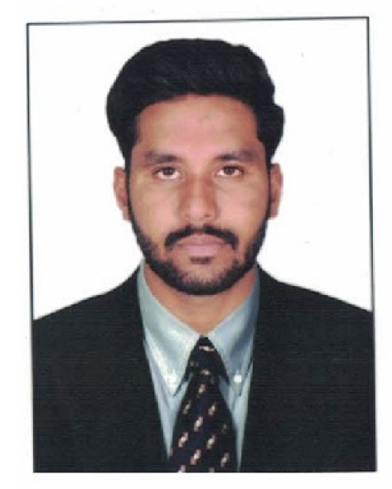 |  |  |  | Manoj Chauhan
- Good communication and interpersonal skills, capable of working under pressure within team or alone Experienced in handling & solving their problems independently with good customers leadership qualities, able to work in a challenging environment & deliver my best performance
Experience

- Inspirisys Solution Limited
- Field Technical Support Engineer
- formerly Accel Frontline Limited
- 12th November, 2018 – 15th June, 2020

- Hitachi Systems Micro Clinic Pvt. Ltd.
- Client :- Yazaki India Pvt Ltd
- Desktop Support Engineer
- 15th June, 2020 - 30th June, 2021

- Microlink Solution Pvt Ltd
- Client :- AIA Engineering Pvt Ltd)
- Technical Support Engineer
- 1st July, 2021 to 6th April, 2022

- NKP PHARMA PVT LTD
- IT EXECUTIVE
- 7th April , 2022 to Present

Education
- Bachelors of Arts
Gujarat University [2021]
- Higher Secondary School Board(12th)
GHSEB [2015]
- Secondary School Board (10th)
GSEB [2013]

Certifications
- JCHNP
Jetking Certified Hardware & Networking Professional
- CCNA
Network Kings by Script Cloud
- MCSA
Network Kings by Script Cloud
- LINUX

Personal Information
Name –Mr. Manoj Chauhan
Father’s Name-Mr.Kantibhai Chauhan
D.O.B- 22ndJanuary,1998
Sex - Male
Marital Status - Married

JOB PROFILE
- I have handled site of 400+ users. Computer and peripherals support Diagnose & Troubleshoot hardware and software problems and replace defective components
- On site desktop support related to OS, MS Office, hardware issues, peripheral devices issues
- Working On Ticketing tool with good written skills
- Taking two times Feedback of users during a month
- Train people in computer system use with Audite
- Coordinate with vendors
- Manage the LAN troubleshooting LAN connectivity Problem
- Managing IT inventory
- Providing the technical support for infra team
- Coordinate with different company for IT Material planning for office
- Providing support on CCTV, door access control ,system biometric attendance
- Handling VIP users calls and provide prompt support resolve the issues on high priority
- Configure WI-FI routers and Network printers. Installing and troubleshooting of various customized application
- User and access management (Password, Folder access, Drive Mapping, Bit-Locker ,Mail box management
- Preparing Daily monthly weekly reports
- Installation and Roll out Service of New Desktop, Laptop and Printers
- Hardware Fault Diagnosis Desktop and Laptop
- Installation and OS Support -Repair / Reinstallation / Fresh Installation
- Taking System In Domain And Workgroup
- First level of support on Desktop - Laptops Under warranty / AMC with Third party vendor and vendor coordinate for L1 and Spare Support
- Installation and Software Support On Office, SAP, Antivirus software, Meeting Software (Lifesize, Skype, Webex, Zoom, Microsoft teams), E-mail client(Outlook), IE, Chrome and Other Business Critical Applications
- Configure and Troubleshooting Network Connectivity of Desktop, Laptops and Network Printers
- Installation / Reinstallation and Configuration of peripherals e.g. Printers, Scanners etc.
- Troubleshooting and Resolution of first level Printer Problems e.g.(Paper jam, Configuration Setting, toner installation, Driver Related Issues)

DECLARATION
I hereby do solemnly affirm that the details furnishedhereare true to the best of my knowledge.

Place-Ahmedabad
Date- Manoj Chauhan
uu
 |  | AHMEDABAD
 |  | +91  6355295938-  9081714862
 |  | manojsinh.chauhan008@gmail.com

https://www.linkedin.com/in/manoj-chauhan-5b9729192

Hobbies

- Playing computer games,
Listening to music
Learn about new technology

Languages
- Hindi
- English
- Gujarati

Technology
- Operating System -Windows 07/08/10

Personal Attributes
- Positive Attitude
- Quick Learner
- Good Communication Skill
- Hard & Smart Working
- Ability to work in any environment
- Teamwork

