satish.drupalchamp@gmail.com

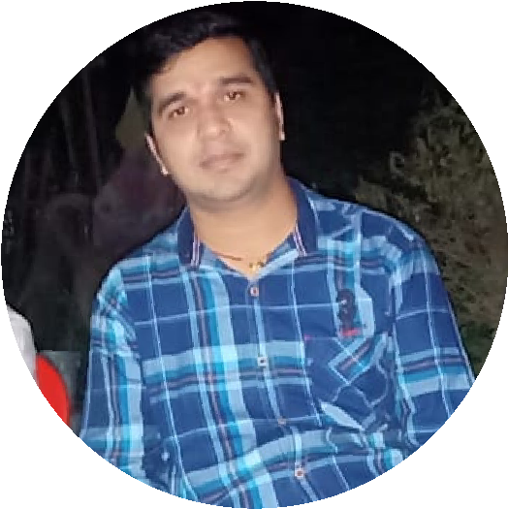

**SATISH KUMAR**

Drupal Frontend Developer

**CAREER OBJECTIVE**

**My Contact**

9724472988 Muzaffarpur, Bihar

# KEY SKILLS

Web Development

Responsive design

Multi Browser Compatibility

Project Management

Site performance

## TECHNICAL SKILLS

Programming Languages: PHP 7.x

Database: MySQL

Web development: HTML5(Responsive

Design), CSS3, Sass

Content Management System: Drupal

(8,9,10), Wordpress

Scripting language: JavaScript, jQuery

Environment: Windows Editing Tools: VS Code Editor, Edit Plus, Sublime Text.

Web Server: Xampp server Version Control System: GIT, Composer,Drush

Bug Tracker, Jira, Click up,

Slack, In Vision

Platform: Pantheon

Core Migration from Drupal 8/9/10

## Education

Aptech Computer Education software engineering course Gujarat) – 2008-2010

Bachelor of Commerce – 2005-2008 (Gujarat

University, Ahmedabad Gujarat) 12th (GSEB. Ahmedabad) – 2005

(Ahmedabad, Gujarat)

10th (GSEB. Ahmedabad) – 2001 (Ahmedabad,

Gujarat)

MCA -2011 -2013(Dropout)

Want to develop my skill with your organization in a developing environment where I can nurture my talent and to grow with Your organization. At an extensive level I want to develop myself as well as your company. Want to make your organization more profitable with my extensive effort and skill.

### SUMMARY

Overall, 3 years of experience in UI/designing, development using

Drupal HTML5, CSS, Sass, JavaScript, Ajax, XML, JSON, jQuery, Rest API, Frontend/Backend Development, Basic Custom Module/Theme development Drupal template through Twig components and many more. Actively working on Responsive / Mobile or IPAD websites to use bootstrap Developing key functions for running websites smoothly on Smartphone / IPADS. Excellent analytical, written, communication skills, ability to work independently and highly motivated. Strong Work Ethics and an earned reputation for meeting deadlines and delivering for mission critical solutions.

# HOBBIES

Cook and eat non-Veg foods.

Watch movies & Music Listening, Cricket Playing.

# PERSONAL STRENGTH

Hard Working with good team player.

Leadership & Problem solving.

Dedicated to job at hand with positive attitude.

## PERSONAL DETAILS

Date of Birth: 15th November 1986

Gender: Male

Father’s Name: Shesh Kumar Singh

Nationality: Indian

Languages Known: English, Hindi ,Gujrati, Bhojpuri

## WORK EXPERIENCE

Software Developer OCT '20 - Present

Douce Infotech Pvt Ltd Muzaffarpur, Bihar India

Software Support Eng. Dec 2012-July 2020

Visual Infosoft Pvt Ltd Ahmedabad, Gujarat India

# PROFESSIONAL EXPERIENC

# Project URL : <https://smallclaimsbc.ca/>

# Project URL :<https://legalclinic.pacificlegaloutreach.com/>

# Project URL : <https://lawlessons.ca/>

# Project URL : <https://blog.bizibuz.com/>

# Project URL : <https://www.armscontrol.org/>

# Project URL : <https://mobileonline99.com/>

# Project URL : https://dev-beacon-unitarian-church.pantheonsite.io/

# Project URL : <https://www.australianpork.com.au/>

# Project URL : <http://go.mayanotisrael.com/>