Curriculum Vitae
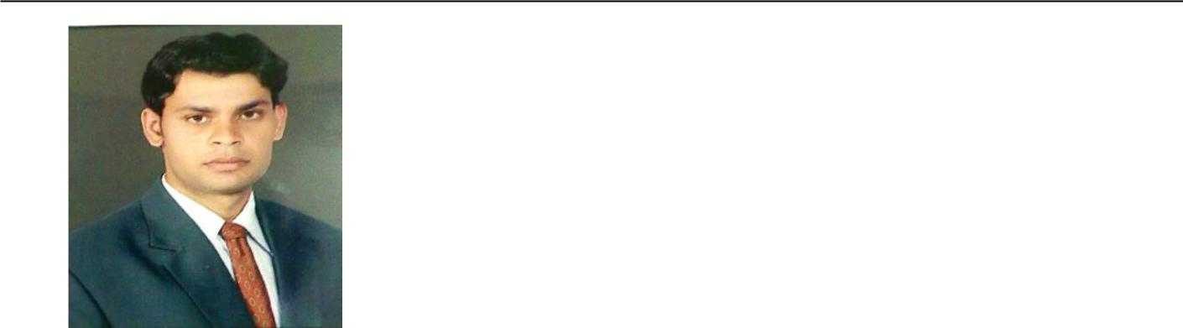

VIKAS SHARMA

- :8905487402,9057607867 Vikassharma.nbmc@gmail.com

Specialization:
Financial Management.
Marketing Management.

Career Objective

To pursue a career with an organisation having a global vision, which encourages creativity and offers an opportunity to learn and develop in professional life, and enhances my knowledge and ability to work in groups.

Professional Qualification:

- MBA from Maharishi Dayanand University (Rohtak-HR) 2009-2011. (Specialization: Finance.)

- PGP From Alesco Business School,(Indore- M.P) 2009-2011. (Specialization: Marketing.)

Education Qualification

Class | Year | Board/University(College) | Subjects
B.com | 2008 | Rajasthan University, Jaipur | Business | admin., A/C& |  | Law,
 |  | (S.K College sikar) (Raj.) | Business | Economics
12th | 2005 | Rajasthan Board, Ajmer | English, Hindi, |  | Economics,
 |  | (S.K school,sikar) (Raj.) | Business org., Accountancy
₁₀th | 2003 | Rajasthan Board, Ajmer | English, | Hindi | Maths, | Social
 |  | (Tegore Bal Nekiten school) (Raj.) | Sc., Science.

Summer Internship –Systematix share & stock India ltd.

Objective - To Analysis of share and open Demat and Trading A/c.

Achievement: Company gave me a Target for opening TEN Demat and Trading A/c and I have achieved this target in a given span of time.

Computer Skills

Operating Systems: Windows
Packages Known: MS Office (Word, PowerPoint, Excel)

Additional Qualification

- Career oriented course

  - (Short hand steno)

  - (Typewriter Hindi and English).

Working Experience
- I have 2 years Experience in LBF Books Publication Pvt. Ltd. Bhilwara (Raj).

    - Promote of Book and Convert into the Sale.

  - I have 2 years Experience in MEWAR Orthopaedic Hospital Pvt. Ltd.(Accounts Manger).
  - Now i am currently working in career line coaching pvt ltd.(Accounts Manger)

Personal Details

……………………………
Date of Birth: 04/06/1988
Languages: Hindi & English.

Parmanent Addresss:
- Vikram Gas Godown, Radhakishan Pura,Sikar.332001(Raj.)

Date:

Place:

(VIKASH SHARMA)

