 |  | ABHINAV PAUL | 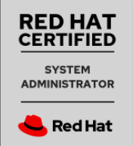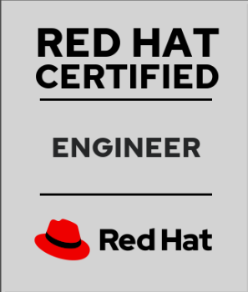
Mobile: | +91 9038475863
E-Mail: | abhipaul2008@gmail.com  abhipaul2009@gmail.com

Having total IT experience of 4 Years on Linux, Control M and hands on experience on AWS Administration. Seeking change to AWS Cloud environment.

Professional Snapshot_________________________________________________________________________

AWS  Cloud/  Linux |  | - Hands on Experience to handle AWS cloud for pre prod and prod environment having EC2 Instance, Load Balancer and Auto scaling and RDS  - Able to monitor server infrastructure with Cloud Watch and reacting based on Cloud-Watch events.  - RDS and VPC Networking implementation hands on experience for a application  - Hosting and creating static website on S3.  - Creation of private network in cloud and deploying web server and database server in them.  - Knowledge on AWS messaging services like SNS, SQS.  - Configuring Cloud-Trail.  - Apache Web Server configuration, installing certificates.  - Working on File permissions and User and Group management for local Linux users.  - Configure IPv4 networking on Red Hat Enterprise Linux systems.  - Configuring NFS server Client, LDAP Client Server Configuration.  - Working on Disk Partitions, LVM.  - Launching AWS Workspace and connecting them with AWS AD.  - Able to deploy Word Press using Elastic Beanstalk.  - Working on Lambda Functions using Python Boto3 library.  - Bash Shell Scripting.

Career Graph__________________________________________________________________________________

July2017 – Till date | Senior Analyst | Capgemini technology services India limited | Kolkata
April 2016 – July 2017 | Analyst (Software Engineer) | Capgemini technology services India limited | Kolkata

Concept and hands on experience on Amazon Web Services: -

- Hands on EC2 creation with EBS, Auto Scaling and Load Balancer for Small Business.
- Creating S3 with Amazon Glacier storage and other storage classes and hosting static web pages using Route 53.
- VPC creation and launching web servers and database servers in them and creating peering connections between private AWS networks.
- Cloud Watch configuration and monitoring them.
- Identity Access Management configuration and implementing Network Access Control List
- RDS configuration with EC2.
- AWS Lambda function configuration.
- Other AWS services and clear understanding of AWS services like SQS, SWF, SNS, Cloud Watch, AWS Config, Cloud Formation.
- Lambda Functions.

Concept and Hands on Experience on RHEL: -

- Disk management.
- Copying, moving and organize files from bash shell prompt.
- Basic Linux commands pertaining to AWS.
- Configure basic IPv4 networking on Red Hat Enterprise Linux System.
- Control access to files with Linux file system permissions.
- Configuring and installing Basic Web Server.
- Managing local Linux users and groups and administer local password policies.
- Monitor and manage Linux process.
- Install and update software packages.
- Created shared NFS file system, mounting and un-mounting NFS server, NFS client on remote machine, sharing remote file folder, starting stopping the NFS services.
- Cron Job scheduling.
- Bash Shell Scripting.

Certifications: -

- AWS Certified Solutions Architect – Associate Validation Number 5DHRBKPKJN1EQCS2

- RED HAT Certified System Administrator CERTIFICATION ID: 190-303-214

- RED HAT Certified Engineer CERTIFICATION ID: 190-303-214

Educational Profile

COURSE | INSTITUTE | BOARD/UNIVERSITY | YEAR OF COMPLETION | PERCANTAGE
B. TECH | BRAINWARE  GROUP OF  INSTITUTION | WBUT | 2015 | 77
INTER-MEDIATE | METHODIST  SCHOOL | ISC | 2011 | 73
SECONDARY | WWA COSSIPORE ENGLISH SCHOOL | ICSE | 2009 | 79

Personal Details
Father's Name | : | Subimal Paul
Mother’s Name |  | Lipika Paul
Date of Birth | : | 20/09/1992
Sex | : | Male
Nationality | : | Indian
PAN | : | CMZPP0933Q
Languages Known | : | Bengali, English, Hindi

Permanent Address | 36/1 Jogendra Basak Road  Opposite Baranagar Police Station  Kolkata 700036
Declaration :
I pledge and pronounce that all the above information is true to best of my knowledge.

Abhinav Paul
Date: 9/5/2020
Place: Kolkata (Signature)

