REHAN ASHRAF    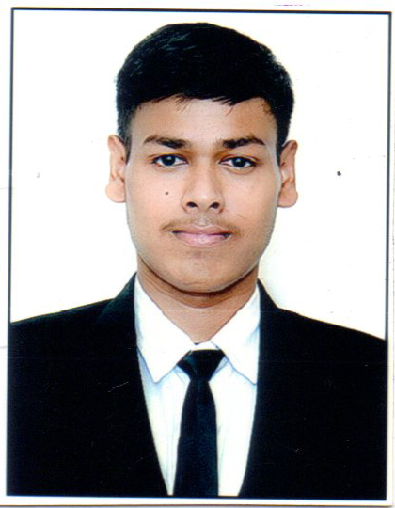  CONTACT  Address: 718/3 joginder enclave near airport circle, ahmedabad, Gujarat.  Mobile :6200636826  Phone:9464039785  Email: ashrafrehan676@gmail.com.  LANGUAGES  English  yes  Gujarati  no  Hindi  yes  German  no  Spanish -no |  | Objective  My ambition is to grow professionally in the field of hotel management. It has been more than a dream to me, as I look forward to grab every possible opportunity which would lead me to a better employee in the field of my interest. And build all possible qualities to provide people the best exposure during my services.  Academic Qualifications  1. May 2015 - completed SSC from Army Public school Ferozpur  2. May 2017- completed HSC rsd rajratan public school(Punjab)  3. March 2018- current- Asia Pacific Institute of management BBAHT(degree in hotel management) city campus.  Extra-Curricular & Co. Curricular  - Running  - Swimming  Achievement  - Win silver medal in relay race in school.  - Win prize in relay race in college.  - Win prize in hand writing competition in school.  Additional Skills  1. Ncc cadet.  Experience  1. Industrial training.  Personal Detail  Fathers Name : Abdul wahab ashrafi  Date of Birth : 05/01/2000  Gender : Male  Marital Status : unmarried  Adhar Card No. : 608209239388

