NAME : JOYEL SAMUEL DIMOCK

DATE OF BIRTH : 27-August-1979

BIRTH PALACE : Ahmedabad

HEIGHT : 5.5 Inch

WEIGHT : 62 KG

ADDRESS : 8, New Lalbhai Center,
Opp Stuti Appartment,
Maninagar East
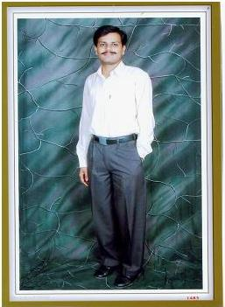
Ahmedabad-380008
Gujarat India

CHURCH
RELATION : Regular Member
Beulah Alliance Church
Maninagar East
FATHER : Samuel A Christian
Son of Late. Arjunbhai G Christian
Late Loisben A Christian
MOTHER : Late Sudhakumari S
Daughter of Late. Mojisbhai M Christian
Late. Febiben M Christian

Brother : Elder Brother Married

EDUCATION : B.Com Graduate Gujarat University.

EXTRA EDUCATION : Having Knowledge of Computer ADIT (Advance
Diploma In Information Technology) Programming And Database Management & SEP (System Engineering Program) Hardware & Desktop Engineering ,MCP (Microsoft Certified Professional)

JOB : Working In Inknowtech Pvt Ltd (Bangalore) at BCCL (Times of India) as System Engineer Ahmedabad. At Present not working will get new job soon.

SALARY : 16128/- Net Salary and 19000/- CTC Per Month

CONTACT : 91-9913722462(M) 91-79-22720244 (R)

