**Dharak Choksi – System Administrator with 8.5 Yrs.**

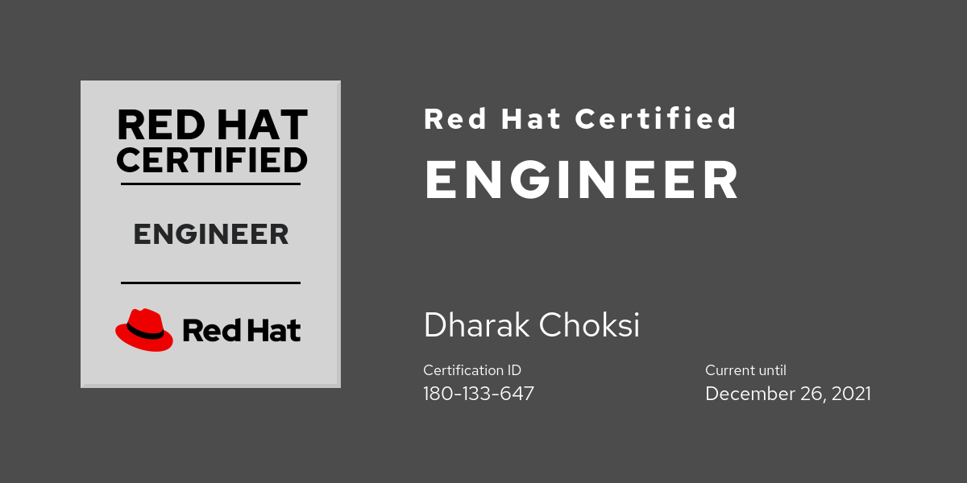

**Dharak Choksi dharak1001@gmail.com**

**(M) +91-97274 63901 dharak101@gmail.com**

**CAREER OBJECTIVE:**

Experienced System Administrator seeking a suitable job position in an organization where I can use my strong analytical, technical skills to improve services & reduce lead time. I am ready to engage myself in new challenges with learning attitude.

**EDUCATIONAL QUALIFICATION:**

|  |  |  |  |  |
| --- | --- | --- | --- | --- |
| **Examination** | **College** | **Board/University** | **Performance** | **Passing Month and Year** |
| B.E.  (Electronics & Communication) | Charotar Institute of Technology Changa | Gujarat University | Aggregate: 70.17% | June’11 |
| H.S.C. | J L High School | GSHEB | 81.20 % | March’07 |
| S.S.C. | J L High School | GSHEB | 86.14% | March’05 |

**JOB EXPERIENCE: 6 Years**

**Sr. Network Engineer at Priya Softweb Solutions Pvt Ltd - Ahmedabad (Nov’16 – Present)**

**Key Responsibilities:**

* Design & Deploy Scalable & Highly Available Azure Infrastructure for Production Applications.
* Provides IT Infrastructure Support to Organization.
* Select Appropriate Azure Cloud Service to design & deploy application based on given requirements.
* Implement Azure Security & Audit Controls to Virtual Machines, SQL Databases.

**Engineer - Projects at Panamax Infotech Ltd – Ahmedabad (Aug’15- Oct’16)**

**Key Responsibilities:**

* + - VPN Configuration & Management
    - Windows/Linux Server Management & Administration.
    - Remote Infrastructure Support in US, UK & EMEA.
    - Manage IT Operations related tasks at Organization.

**Network Executive at Krish TechnoLabs Pvt Ltd – Ahmedabad (Jan’13 – Aug’15)**

**Key Responsibilities:**

* IT Infrastructure Setup at Organization.
* Windows/Linux Server Administration & Support.
* Configuration of Network Security & Management using firewall Device.
* Microsoft Windows OS & Adobe Softwares license management.
* Provides End User IT Support at Organization.
* NAS Storage Device Configuration & Performs Backups for Users’ at Organization.

**IT Support Engineer at SourcePro InfoTech Pvt Ltd – Ahmedabad (Jan’12 – Jan’13)**

**Key Responsibilities:**

* Server Monitoring & Management, IT Infrastructure Planning.
* Provide Remote Technical Support to Users.
* Configuration of User Accounts, Groups, Domain Controller & Terminal Services.
* Backup Process & Scheduling, Antivirus Server Installation & Configuration.
* Citrix XenServer & XenApp Installation, Configuration & Management
* Troubleshooting PC Hardware, OS & Network Related Issues.
* IT Infrastructure Support to Clients like **KHS India**, **GCCI**, **Mamta Machinery Pvt Ltd** etc.

**PROFESSIONAL TRAINING:**

1. Trainee Network Engineer at CMC Ltd (Tata Enterprise) – Ahmedabad (Oct’11 – Jan’12).

2. Project Trainee at Alcatel-Lucent NMS Ltd– Ahmedabad (Jan’11 – May’11)

3. Red Hat Certified System Administrator at Electro mech Corporation – Ahmedabad (Nov’17 – Feb’18)

4. Red Hat Certified Engineer at Electro Mech Corporation – Ahmedabad (Aug’18-Oct’18)

**ACHIEVEMENTS:**

1. **SourcePro InfoTech Pvt Ltd**
   * + - Citrix XenApp Server Setup at Client’s Site.
       - Windows XP to Windows 7 OS Migration of Client’s 200 Users with their data backups.
2. **Krish TechnoLabs Pvt Ltd**
   * + - Windows 7 to Linux Mint OS Migration of Magento Developers
       - Licensing of Windows OS, Ms Office & Adobe Softwares.
       - VNC Infrastructure Setup at Organization on Both Windows/Linux Systems.
       - Successful Completion of Backup Scheduling of 120 Users in Network attached Storage device within 2 Months.
3. **Panamax Infotech Ltd**

* Site to Site VPN Connections Migration from One Lease line to another lease line.
* SNMP Setup in all the VMs in VMware ESXi.
* Critical Support for Panamax Homesite IIS Errors Resolution.

1. **Priya Softweb Solutions Pvt Ltd**

* Anti-Ransomware & DDOS Security Updater Quick heal DLP Seqrite Product Installation in all machines at organization.
* Cyberoam Firewall Upgradation From 200Ing to 500ing XP Version with all the users, Live IPs, IPSec VPNs & all web filter/application filter policies.
* ACL Setup with necessary permissions of Client’s Digitalocean Production Server.
* Manage 24*7 Softweb Hackathon 2016 Event along with team by providing Network Support & Live Recording of Event to Hackathon 2016.
* Multiple Frontend Azure Load Balancer Setup for Production Scenario with High Availability & Fault Tolerance.
* Created Azure Windows VM Master Hardened Image with all required components & Azure Bastion Host Setup Security for Client.

**CERTIFICATIONS:**

1. Cisco Certified Network Associate (CCNA) Exploration by CITC in July 2010.
2. IT Professional by CMC Ltd – Tata Enterprise in April 2012.
3. Microsoft Windows Azure Knowledge Certification by Computer Society of India in April’17.
4. Red Hat Certified System Administrator Certification (Certification ID: 180-133-647)
5. IBM Blockchain Essentials in June 2018.
6. Red Hat Certified Engineer Certification (Certificate ID: 180-133-647)

**PERSONAL STRENGTHS:**

* Positive Attitude
* Pro-Active
* Honest
* Good Communication Skills
* Good Team Player
* Time Management

**AREA OF INTEREST:**

1) Cloud Infrastructure Management

2) Cloud Security

3) IT Infrastructure Value Addition

**PERSONAL INFORMATION:**

**Name**  : Dharak Choksi

**Father’s Name** : Dipakkumar Chokshi

**Birth Date** : 11th February 1991

**Nationality** : Indian

**Gender**  : Male

**Marital Status** : Married

**Languages Known** : English, Hindi, Gujarati

**Present Address** : B/16, Shivam Bungalows II, Near Sobo Center,

Gala Gymkhana Road, South Bopal,

Ahmedabad - 380058

**REFERENCE:**

Will be produced upon request at the time of Interview.

**DECLARATION:**

I do hereby declare that the information mentioned above is true and correct according to my knowledge and belief.

Place: Ahmedabad

Date: 20/10/2020 **Dharak Choksi**